
Green Society Public School
D- 20
Ratnanagar-7, Sauraha, Chitwan
Third Terminal Examination-2082
Class: Four Time:2 hrs. F.M.:50
Sub: Math’s
- Answer the following questions.
- Draw a line segment AB.
- Using a protector, draw 30⁰ at A 60⁰ at B. [2]
- Name the point where the two lines meet as C, Write the measure of $∠$ACB. [2]
- Look at the figure and answer the questions.
- Name the plane figure. [1]
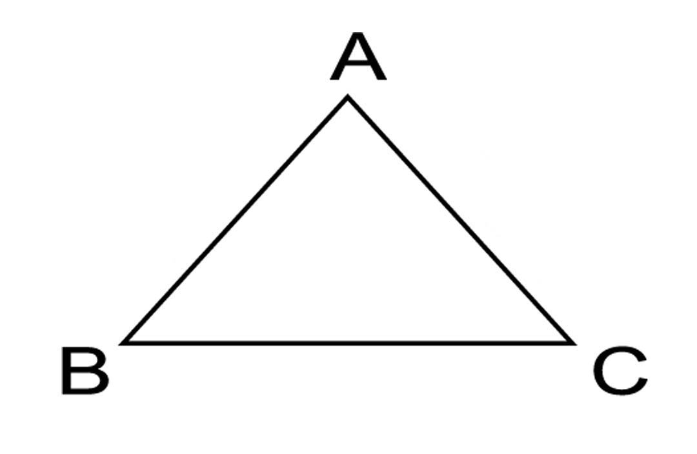
- Write the measures of sides using a ruler. [2]
- Draw a plane figure having four sides using a ruler. [1]
- How many vertices are there in a square ? [1]
- Observe the figure and answer.
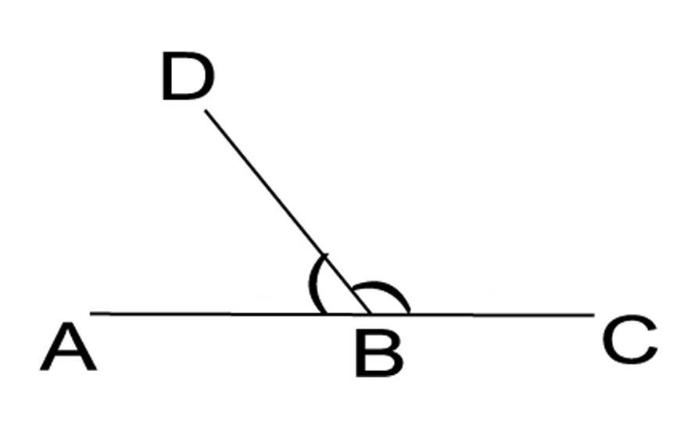
- Write the names of angle $∠$ABD & $∠$CBD. [2]
- Which is the greater angle & which is the smaller angle ? [1]
- How much should be added to the smaller angle to make it equal to the greater angle? [2]
- Answer the following.
- What is the place value of 5 in the number 34758 ? [1]
- Write 34758 in expanded form. [2]
- Show 34758 in a place value chart. [2]
- Find the difference between the greatest and smallest three digit number. [2]
- Sujan wants to buy a TV and a laptop. The cost of the TV is Rs. 28,345 & the cost of laptop is Rs. 39,676.
- Which mathematical operation is used to find the total cost ? [1]
- Find the total amount needed. [2]
- If Sujan has Rs. 68,000 how much more money does he need ? [2]
- A dice is shown.

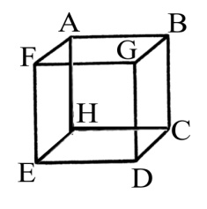
- How many vertices does the dice have ? [1]
- If A is a vertex, what is AB called ? [1]
- How many faces does a dice have ? Name the solid shape. [3]
- Answer the following.
- Round 37 to the nearest ten. [1]
- Compare using <, > or = [2]
- 78435 ________87345
- 55000 ________5000
- Solve [2]
- 246+479-144
- Fill in the blanks. [5]
- A pentagon has ________sides.
- The face value of 2 in 3423501 is ______________
- 125$÷$5 = _____________
- The formula of perimeter of rectangle is ________________
- The place value of 8 in 832 is ______________
- a) The length of a rectangle is 8cm & its breadth is 6 cm. Find its perimeter. [3]
b) There are 11 players in a football team. How many players will be there in 75 terms ? [2]
c) There are 60 minutes in 1 hour, how many hours are there in 720 minutes. [2]
- Classify the following angles (Acute angle, Right angle, Obtuse angle, straight angle). [2]
120⁰, 180⁰, 50⁰, 90⁰.

Best of Luck

